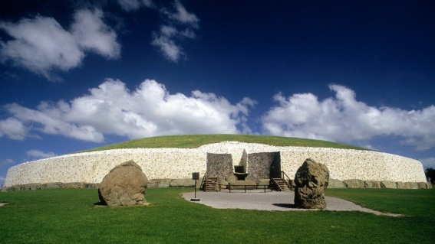
Where is this monument?
- Sicily
- Ireland
- Poland

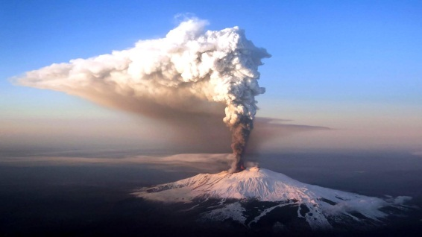
What volcano is this?
- Etna
- Mount Everest
- Mount Fuji
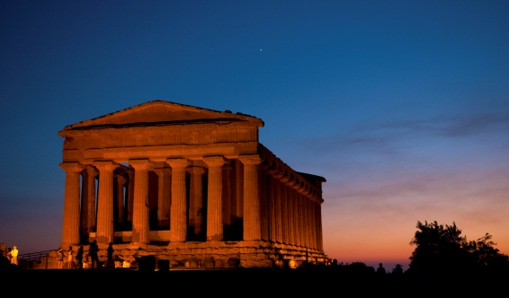
Is this monument in UNESCO?
- Yes
- No

Who has the most monuments?
- Ireland
- Poland
- Lithuania
- Italy
How many are UNESCO monument in Czech Republic ?
- 12
- 14
- 16
"The European Commission support for the production of this publication does not constitute an endorsement of the contents which reflects the views only of the authors, and the Commission cannot be held responsi¬ble for any use which may be made of the information contained therein."
