"The European Commission support for the production
Our Best
For
Heritage
Year 1
of this publication does not constitute an endorsement
of the contents which reflects the views only of the authors,
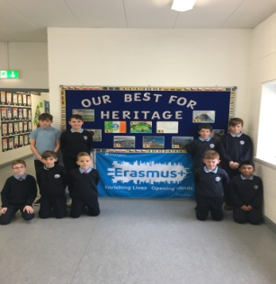
and the Commission cannot be held responsible for any use
which may be made of the information contained therein."
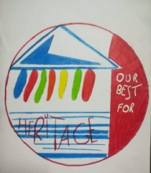

We started our Erasmus project in September 2018. Our project is based on UNESCO sites and is called “Our Best for Heritage”. We are working with our other partners from Czech Republic, Poland, Italy and Lithuania. One of our first tasks was to set up an Erasmus Club. There are nine boys in our club as well as 3rd and 6th class taking part in the project. We were very busy getting the club up and running as well as voting on the project logo and setting up the project notice board.
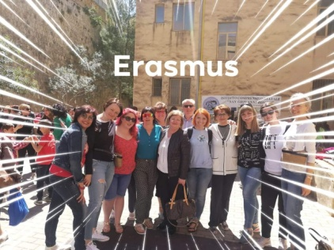
During October the boys were very busy coming up with ideas for merchandise that we would have for our project. The boy’s ideas were great. We decided to create the Newgrange stone carvings. During December we sold our creations at a Christmas fair in our school hall. The Erasmus club really enjoyed talking to people that day and telling them about our project.
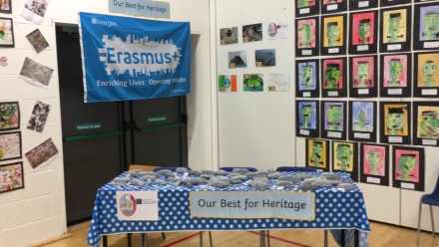
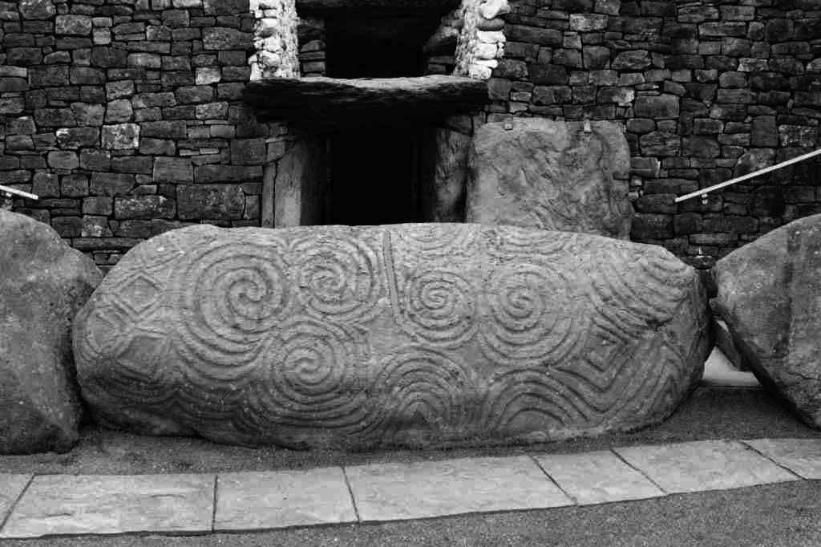

After Christmas it was very busy learning all about our local UNESCO Site – Newgrange. We created tourist guides about Newgrange in both English and Irish which we shared with the other members of the project. They also sent us their tourist guides from their local UNESCO Sites. The boys really enjoyed reading these. We took boys from 3rd and 6th class to visit Newgrange and boys from 3rd class had fun making a video of their trip to Newgrange. They learned lots about Newgrange and enjoyed follow up lessons based on it.
In May Ms Carragher and Ms Gerrard travelled to Sicily to meet up with the other project partners for the second short term exchange of the project. Throughout the week there were coordinators meetings, activities based on the project and of course a visit to their famous UNESCO Site – Mt Etna! It was a great trip!
To round off the year we had a project day in our school hall. We had representatives from the local community in to see the work we were doing. Everybody enjoyed the day and loved hearing about our project!

